Did the Creators cheat at the casino?
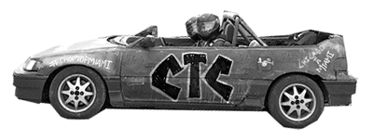

In the final challenge of the Chop Top Challenge, teams were each given $10 to bet on the roulette table using an “all or nothing” strategy. To keep it simple, teams were only allowed to pick red or black. Each team plays until they lose.

- The teacher will be in charge of the roulette wheel. Your team will play until you lose. How many wins did you get?

- Write the number of wins on a sticker dot and take it to the poster at the front of the room. Sketch the dotplot below.

# wins in a row

- The Creators walked away from the roulette table with $640 (5 wins in a row!). Is this outcome surprising for a team that is simply guessing? Explain.

- Based on the simulation, do we have convincing evidence that the Creators cheated? Explain.

