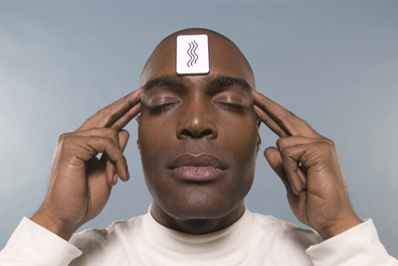
Can You Guess the Rainbow?

Use your extrasensory perception to guess the flavor for each Skittle. What proportion will you get correct?

Working in pairs, test your partner’s ability to “guess” the flavor for a sample of 50 Skittles.

Collect data: Number correct: ______ Total: ______ Proportion correct: ______

1. Write the “Proportion correct” on a sticker dot and add it to the dotplot on the board. Sketch the dotplot below.

Proportion correct

2. What does each dot represent?

3. Shape: Describe the shape of the dotplot.

4. Center: What value appears to be at the center of the dotplot?

5. Variability: Remember that standard deviation describes the typical distance a value is from the mean. Estimate the standard deviation for the dotplot.

