What is Pamela’s Current Speed? Name:___________________________

Activity trackers and smartwatches can help you gain valuable data about your exercise routine. Runners often use them to keep track of mileage, pace, calories, and steps. Today we will explore some of the measurements in greater detail.
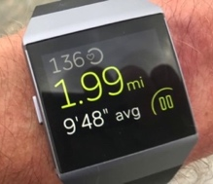

- In the middle of her run, Pamela looks down at her Fitbit screen and sees that she is currently running at a pace of 8’45”. The next screen shows an average pace of 9’48”. How is this possible? Why might these two numbers differ?

- Look at the summary report of Pamela’s run. What is her average speed, in miles per minute?
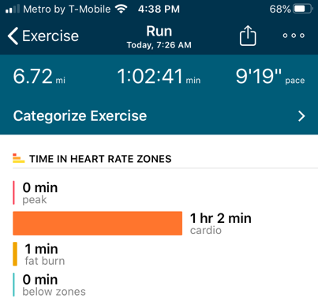

Below is a graph showing Pamela’s distance traveled with respect to time (in minutes).
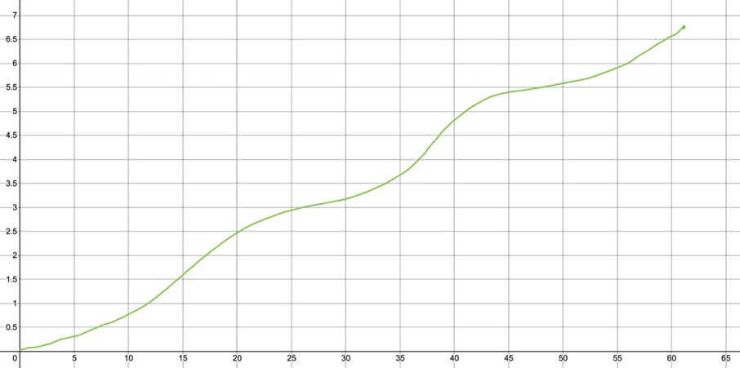
Distance (miles)
- How could you use this graph, instead of the summary report, to calculate Pamela’s average speed?

- Was Pamela running at a constant speed? How do you know?
Time (minutes)

- What time does it look like Pamela is running the fastest? How can you tell?

- How do you think Fitbit is able to capture a current speed at any time during the run?

Section 9.1—Average versus Instantaneous Rate of Change
Important Ideas:

Check Your Understanding!
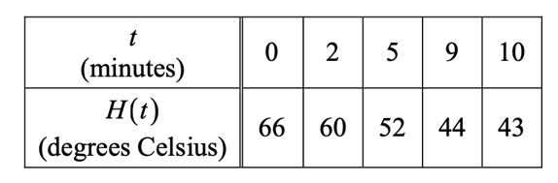
- The temperature of a pot of tea as it is cooling is given by the function $H(t)$, measured in ˚Celsius. Time, t, is measured in minutes.

  - How fast is the tea cooling, on average, over the ten minute interval? Show work and include units.

  - Estimate the rate at which the temperature of the tea is changing at $t=3.5$. Explain your method.

- Find the average rate of change of $f\left(x\right)=\sqrt{3x+4}$ on the interval [-1, 4].

- Which is greater: the instantaneous rate of change of $f\left(x\right)=\sqrt{3x+4}$ at $x=0$ or at $x=4$? How do you know?

- The graph of $g(x)$ is shown to the right.
  - Find the average rate of change of $g(x)$ on the interval $[0,2]$. Show work.
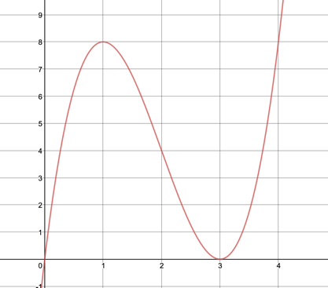
$$g(x)$$
  - Order the following from 1=least to 4=greatest:

_____Average rate of change on $[0, 3.5]$
_____Instantaneous rate of change at $x=1$
_____Average rate of change on $[1,3]$
_____Instantaneous rate of change at $x=0.5$

